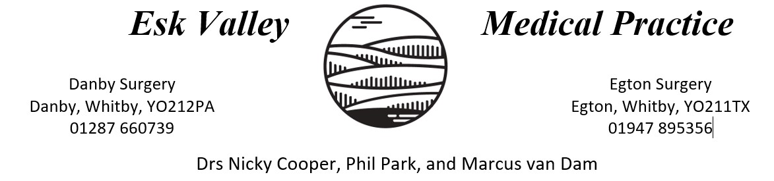

Infection Control Annual Statement Report
6th November 2023
Purpose
This annual statement will be generated each year in November, in accordance with the requirements of the Health and Social Care Act 2008 Code of Practice on the prevention and control of infections and related guidance. The report will be published on the practice website and will include the following summary:
- Any infection transmission incidents and any action taken (these will have been reported in accordance with our significant event procedure)
- Details of any infection control audits carried out, and actions undertaken
- Details of any risk assessments undertaken for the prevention and control of infection
- Details of staff training
- Any review and update of policies, procedures, and guidelines
Infection Prevention and Control (IPC) lead
The lead for infection prevention and control at Esk Valley Medical is Catherine van Dam, Practice Nurse.
The IPC lead is supported by Liz Pollock, Practice Nurse
a. Infection transmission incidents (significant events)
Significant events involve examples of good practice as well as challenging events.
Positive events are discussed at meetings to allow all staff to be appraised in areas of best practice.
Negative events are managed by the staff member who either identified or was advised of any potential shortcoming. This person will complete a Significant Event Analysis (SEA) form which commences an investigation process to establish what can be learnt and to indicate changes that might lead to future improvements.
All significant events are reviewed and discussed at several meetings each month. Any learning points are cascaded to all relevant staff where an action plan, including audits or policy review, may follow.
In the past year, there have been zero significant events raised which related to infection control. There have also been zero complaints made regarding cleanliness or infection control.

b. Infection prevention audit and actions
Hand Hygiene
Aseptic Technique
Personal Protective Equipment
Safe Management of Care Equipment and Environment
c. Risk assessments
Risk assessments are carried out so that any risk is minimised and made to be as low as is reasonably practicable. Additionally, a risk assessment that can identify best practice can be established and then followed.
In the last year, the following risk assessments were carried out/reviewed:
- COSHH
- Cleaning standards
- Legionella & Water safety
- Needle stick injury and exposure to bodily fluids
- Upholstered furniture
- Curtain rail systems
d. Training
In addition to staff being involved in risk assessments and significant events, at Esk Valley Medical Practice, all staff and contractors receive IPC induction training on commencing their post. Thereafter, all staff receive refresher training annually.
e. Policies and procedures
The infection prevention and control-related policies and procedures that have been written, updated, or reviewed in the last year include, but are not limited, to:
- Infection Prevention Control
- Cleaning Standards and Schedule
- Safe water
- Health & Safety
- Accident Reporting
- Staff Immunisation
Policies relating to infection prevention and control are available to all staff and are reviewed and updated annually. Additionally, all policies are amended on an ongoing basis as per current advice, guidance, and legislation changes.
f. Responsibility
It is the responsibility of all staff members at Esk Valley Medical Practice to be familiar with this statement, and their roles and responsibilities under it.
g. Review
The IPC lead and Practice Manager are responsible for reviewing and producing the annual statement.
This annual statement will be updated on or before 7th November 2024

Signed by
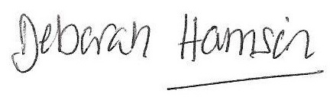
Deborah Harrison

For and on behalf of Esk Valley Medical Practice

